Intel QuickSPI
(HIDSPI over Touch Host Controller)
Driver Release Notes

WW12’2022
Driver Version: 4.0.0.30
- Mohammed Abdul, Haseeb (Abdul)

Contents
1. Introduction 5
1.1 Document Scope 5
2. Intel QuickSPI Driver Package 6
3. Supported Configuration 7
4. Feature implementation/Fixes 8
5. Known Limitations 9
6. HW Setup with HIDSPI PCB 10
7. BIOS Menu Configuration 12

Revision history
Driver Revision Number | Description | Revision Work Week
4.0.0.29 | Initial release for QuickSPI driver based on MSFT HidSpiCx | WW51, 2021
4.0.0.30 | Q1’22 Major quarterly release of QuickSPI driver | WW12, 2022

Acronyms
Term | Description
QuickSPI | Intel developed Windows driver for HidSpi over Touch Host Controller
THC | Touch Host Controller within the chipset that supports SPI based host controller interface to touch devices
SPI | Serial Peripheral Interface. Synchronous serial communication bus used to attach peripherals to motherboard. In the ADP-P and MTL chipset, there are two instances of THC-SPI host controllers.
ACPI | Advanced Configuration and Power Interface – for this specification we are assuming ACPI 5.0
HidSpi | Microsoft defined specification that defines the protocol, procedure, and features for input devices to communicate using HID protocol over SPI interface
HidSCx | Microsoft defined Serial Class Extension framework for HID over Serial Buses. The class extension is defined for clients which implement v1.0 of hidspi protocol
SoC | System on Chip
WDK | Windows Driver Kit
RPL | Raptor Lake Platform
ADL | Alder Lake Platform
MTL | Meteor Lake Platform
WoT | Wake on Touch

Introduction
This document specifies the driver release notes for QuickSPI driver, which is based on Intel’s Touch Host Controller (THC) subsystem.

Document Scope
This document was written to guide on QuickSPI Driver releases for Windows Cobalt OS on CCG platforms starting from RPL, supporting other platforms like ADL-N, MTL. This document will focus on the Driver package content, HW setup (used for validation of driver), BIOS menu config, driver changes (feature implementations/fixes) and known limitations.

Intel QuickSPI Driver Package

Driver Version: 4.0.0.30
Content Overview

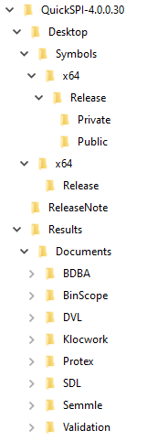

Supported Configuration

Target Platforms:
- RPL-P/Px/Hx
- ADL-N/P
- MTL-M/P/H
Windows OS:
- Cobalt OS
EWDK:
- 22000.Co.1052
HIDPSI Panel used for validation:
- Wacom (BOM6)
SPI Interface cable:
- 10-16 pin SPI (1.8V)

Feature implementation/Fixes

- Unified driver for ADL-P (with A1 Si)/RPL/MTL
- Driver changes to align THC register mapping for MTL platform
- WoT related fixes.
- Error handling scenarios
- THC frequency should be limited to the lowest and closest validated SPI frequency.
7.8125MHz and 31.25MHz are the min and max validated SPI frequencies.
- Implemented the code change to avoid second PioRead, while reading the Device Descriptor.
22014560486 [Surface][Intel QuickSPI]: Driver does a second PioRead when reading Device Descriptor.
- Details of all the above fixes on top of 4.0.0.29 are available @ https://github.com/intel-innersource/drivers.platform.ipts.hspi-driver/pull/21

Known Limitations

- WoT doesn’t work with single tap, need to use double tap or delayed drag for swipe.
- Touch is not functional in Safemode and WinPE mode.
- Single and Dual IO Mode functionalities on HIDSPI BOM6 panel are verified, but Quad mode couldn’t be verified due to panel limitation.
- Dual IO Mode functionality can be verified till max 25MHz connection speed, due to panel limitation.
HSD’s:
id | Title
16015197357 | [ADL-P/RPL-P/Px] [QuickSpi][Cobalt]::Unexpected Reset Notification from HIDSPICx during Wake On Touch (PUID 575905)
16015290403 | [ADL-P][QuickSPI]YB observed on QuickSPI driver in safemode
15010866040 | [ADL-P][QuickSPI][Cobalt] Touch is not functional in WinPE environment

HW Setup with HIDSPI PCB

- Current driver package is validated with below HW setup.
SHARP LQ0DASE170
110700425W00
3342-20Y06-1-CW70782
WACOM PWB-D893(X)
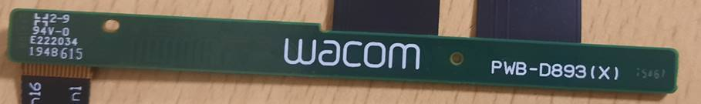

Touch Cable 10-16 pin SPI (1.8V)
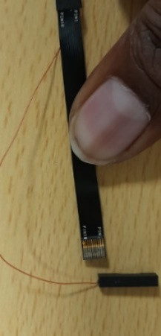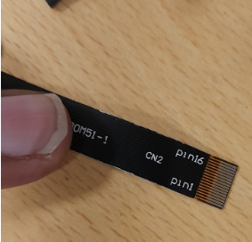

Name | Platform | Display | Touch Vendor | Touch Protocol (Firmware) | Touch Cable | eDP Cable
BOM6 | ADL | Sharp 12.5" 1W | Wacom G14T Fusion PCBA | HID-SPI over THC | 10-16 pin SPI (1.8V) | 60-pin

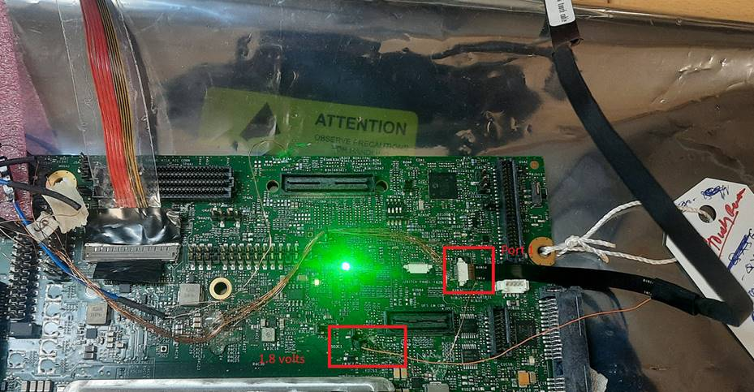

BIOS Menu Configuration

Below values can be configured by the user from BIOS menu, which are specific to Wacom (BoM6) panel.
BIOS settings for Single IO mode:
Intel Advanced Menu àPCH-IO Configurationà THC configurationà THC1à Enabled
THC MODEà HID Over SPI
Input Report Body Address à[1000]
Input Report Header Addressà[0]
Output Report Address à [4]
Write Opcode à [2]
Read Opcode à[B]
Intel Advanced Menu àPCH-IO Configurationà THC configurationà HID Over SPI Limit Packet Size à[1]
Intel Advanced Menu àPCH-IO Configurationà Security Configurationà Force unlock on all GPIO pads → “Enabled”

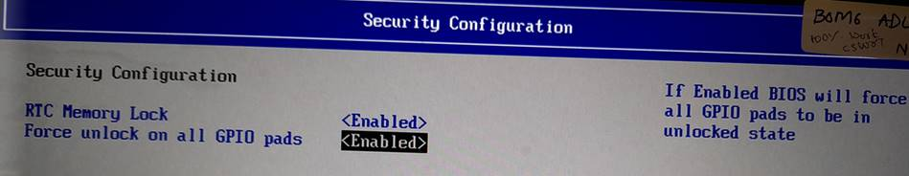

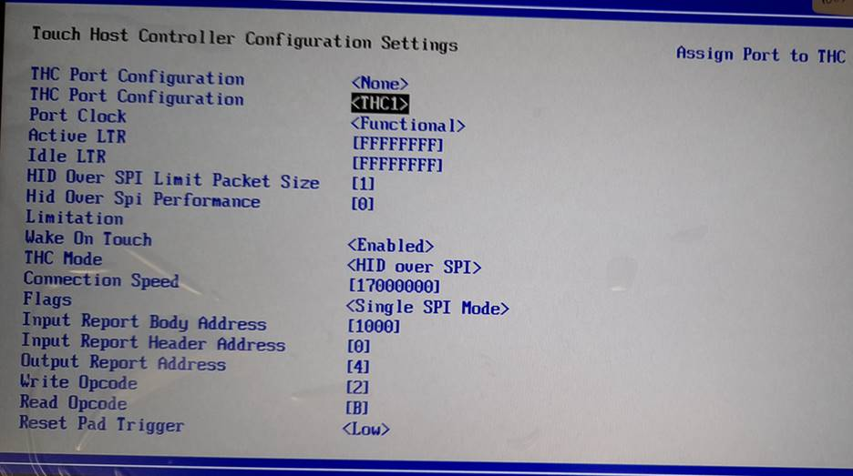

BIOS Setting for Dual IO mode:
Flash the latest Released IFWI and do the Below BIOS settings.
- Intel Advanced Menu à PCHIO Configuration àTHC Configuration à THC Port Configuration à THC1 or THC0
- Intel Advanced Menuà PCHIO ConfigurationàTHC Configuration à HID Over SPI Limit Packet Sizeà 1
- Intel Advanced Menuà PCHIO ConfigurationàTHC Configuration à THC Port Configuration àTHC Mode à HID OVER SPI.
- Intel Advanced Menuà PCHIO Configurationà THC Configuration à THC Port Configuration àInput Report Body Addressà [1000]
- Intel Advanced Menuà PCHIO ConfigurationàTHC Configuration à THC Port Configuration à Input Report Header Addressà [0]
- Intel Advanced Menuà PCHIO ConfigurationàTHC Configuration à THC Port Configuration à Output Report Addressà [4]
- Intel Advanced Menuà PCHIO ConfigurationàTHC Configuration à THC Port Configuration à Write Opcodeà [2].
- Intel Advanced Menuà PCHIO Configurationà THC Configuration à THC Port Configuration à Read Opcodeà [BB].
- Intel Advanced Menuà PCHIO ConfigurationàSecurity Configurationà Force Unlock All GPIO Padsà Enabled

